The Relationship Between Race and Impression Management

by

Dean Nguyen

**Abstract**

Existing research have shown how negative stereotypes affect perceptions of nonwhite employee’s work performance. There is also evidence of lower performance evaluations on nonwhite employees relative to white employees. Research has also shown how stereotypes alter perceptions of minority groups’ likeability. However, there is a lack of empirical evidence to date about how nonwhite employees deal with those stereotypes, such as by changing their behaviors to influence other’s perceptions of them within the workplace (known as impression management). This thesis attempts to provide insight on this category of impression management by exploring the differences between how white and nonwhite employees behave in different scenarios to influence how likeable and competent they are in the workplace. I find evidence that nonwhite employees display higher degrees of impression management around competency compared to white employees. I theorize that competency behaviors are more directly tied to promotions than likeability behaviors.

Key words: Impression management, race, workplace

**1. Introduction**

Racial stereotypes negatively affect minorities. For example, within America, Asians are the least likely racial group to be promoted into roles of management (Gee & Peck, 2018). This finding is contrasted by the author’s findings that whites are about twice as likely to be promoted into management. The authors suggest that stereotypes about Asians lacking social skills as a possible reason for lack of promotions. Blacks face a similar situation, with one study finding that managers perceive Blacks as lacking in “soft skills” such as likeability (Moss & Tilly, 1996). Meanwhile, studies have shown that, compared to minorities, whites are implicitly associated with leadership traits (Gündemir et al., 2014).

How do minority groups address these stereotypes in the workplace? One possible answer is through impression management, where individuals behave in a certain way to influence how others perceive them (i.e. complimenting coworkers to increase likeability or reminding others of their achievements to show competency). This study aims to assess whether there is a difference between whites and minorities in their use of impression management behaviors.

The numerous studies suggesting minorities face unfair biases suggest that minorities will be forced to increase their likeability and competency perception to gain a fairer chance at performance evaluations. In addition to biases, manager racial composition may affect impression management behaviors, as studies have shown Blacks have a higher chance of being negatively rated by a white manager (Stauffer & Buckley, 2005). Lastly, the team’s diversity may come into play as well. Research has shown that minorities who are the sole representative of their racial group perform worse than when whites are soloed (Sekaquaptewa & Thompson, 2002).

To examine these variables, a multivariate regression tests was conducted on survey data from a large company to see the relationship between employee race, manager race, workgroup racial composition and impression management behavior. Through my analysis, I found that nonwhite employees display higher impression management behaviors around competency compared to white employees, except when they are in majority white employee workgroups.

By addressing impression management behaviors discrepancies between white and nonwhite employees, this paper will give insight into the disadvantages that minorities are facing in the workplace. The study will address a gap in literature about race and impression management behavioral studies within the workplace. Implications for future research on will be discussed as well.

The next section explores the current literature around racial stereotypes affecting performance evaluations, attitudes in the workplace, and performance-related impression management behaviors. Following that, I present my three hypotheses around impression management around likeability and competency in different scenarios. Afterwards, I discuss the survey, variables, and regressions used to analyze my hypotheses. Lastly, I present the results, discuss their significance, and suggest future areas of study.

**2.0 Literature Review:**

There are many published studies discussing individuals of different races having biased performance evaluations. Depending on the race of the rater and ratee, there has been mixed prescriptions of the effect against minorities and whites, but there is evidence that Blacks are at a disadvantage. Stereotypes may also have an impact in the racial differences in workplace/career attitudes. Furthermore, the threat of biases and stereotypes on minorities also interplays with the different impression management behaviors that deal with those negative forces. The following section describes the research findings and how the factors are related to one another.

*2.1 Effect of race and performance evaluations*

It is important to recognize the relationship of racial differences between an evaluator and ratee because of discrepancies of ratings between whites and minorities. Yet past literature is inconsistent in describing the effects of the bias. One study found that, after controlling for worker productivity within sales, evaluators tend to rate members of their own race higher (Mount, et. al, 1997)). However, another study found that both Blacks and Whites give lower ratings to Blacks and higher ratings to whites (Sackett & DuBois, 1991) Meanwhile, another study concluded that there is no bias existing within supervisory relationships (Landy, Shankster, & Kohler, 1994).

Although research may be inconsistent, developments have been made, showing that systematic biases d­­­­­­­­o exist, and it is in favors of whites compared to Blacks. Stauffer and Buckley (2005) disproved conclusions of no bias existing in performance evaluations by reexamining past research data. Stauffer and Buckley discovered major flaws in previous studies. For example, research that did find statistical significance in the interaction between race and performance evaluations dismissed the conclusion because of the effect was not practically significant. This means that the percentage of variance accounted for is too small. However, by reevaluating the data, the numbers were indeed large enough to be significant. When examining Sackett and Duboi’s (1991) research which inferred that there was not any bias, Stauffer and Buckley found that their question was too restricted and overlooked racial bias as the cause.

As a result, Stauffer and Buckley (1991) conclude that biases exist in favors of whites compared to Blacks. The authors described in the following way: “If you are a White ratee, then it does not matter whether your supervisor is Black or white. If you are a Black ratee, then it is important whether your supervisor is Black or white.” This research prompts the question if biases how biases may be play out in different manager race to employee combinations. Furthermore, although these studies explain that Blacks receive lower performance reviews, they don’t provide insight on how the threat of biases and other factors affect attitudes in the workplace.

*2.2 Differences in job attitudes and workplace experiences by race*

To fully understand how race relates to different behaviors in the workplace, it is important to analyze the different experiences of whites compared to Blacks. For example, one study examined how race is related to organizational experiences, job performance, and career outcomes by comparing Black and white managers (Greenhaus, Parasuraman, & Wormley, 1990). The researchers sent a survey to Black/white managers with similar qualities (age, employment in organization service, job function, organizational level). The survey asked about isolation, how often they made their own managers aware of assignments they wanted, and other career related questions towards advancement. Within the study, manager’s supervisors also conducted a performance evaluation and the career advancement of the managers. The study’s results showed that, compared to whites, Blacks felt less accepted, felt they had less discretion on their jobs, received lower performance evaluations/promotability, were more likely to reach career plateaus, and experienced lower levels of career satisfaction.

Although this study provides insight on different attitudes in the workplace, it is limited by the fact that it compared only Blacks and whites. Different minorities may feel experience higher/lower aptitudes of attitudes due to different racial biases/circumstances. For example, Asian Americans may have worse attitudes in certain areas, stemming from the fact that they are the least likely racial group to be promoted to management roles (Gee & Peck, 2018). It is also necessary to investigate how different races deal with these negative factors within their everyday behavior at work, as discussed below.

*2.3 Performance related impression management behaviors*

The implication of bias within performance evaluations and negative attitudes in the workplace suggest that minorities may act in different ways to present their worth for higher ratings within performance evaluations compared to whites. One possible way minorities counteract against biases is through impression management, which Bolino and Turnley (1999) define as the act of seeking to influence the image others have of them. One type of impression management is social-identity based impression management, where individuals influence their sense of group identity (Tajifel & Turner, 1979). For example, one study found that British Black Caribbean professionals de-emphasize their ‘blackness’ to avoid the negative stereotypes associated with their group (Kenny & Briner, 2013). In contrast, another study found Asian-Americans, who are often stereotyped as having poor social skills, make jokes about race to avoid their negative stereotypes (Susuki, 2002). These studies suggest that different minorities groupings use different impression management techniques to combat against biases associated with their race.

As suggested by the studies on biases, different racial groups face different stereotypes amongst the lines of competence and likeability. Cuddy, Fiske, and Glick’s study (2004) found that middle class, Christian, and white group are found as both high on competence and likeability, while Asian-Americans are high on competence but low on likeability. Asians and other groups rated similar were found to elicit envy that involved both hostility and depression. The authors found that depending on the group’s likeability and competence ratings, groups face different helpful or harmful stereotype effects.

In addition to social-identity based impression management behaviors, there exists explicit performance evaluation techniques such as ingratiation and self-promotion. Ingratiation, as described by Jones and Pittman (1982), is a behavior associated with likeability and acceptance of an individual. Meanwhile, the authors describe self-promotion as the act of showing competence and mastery. These behaviors may be demonstrated by individuals who desire to influence supervisors for higher performance evaluations. For example, Gordon (1996) found positive effect between ingratiation tactics and performance evaluations.

As shown, there are many studies that discuss the relationship between race and performance evaluations, as well as studies explaining the different behaviors to combat those biases. These studies find that, compared to whites, minorities often face the threat of lower performance evaluations because of stereotypes and biases. These individuals often have negative workplace experiences from biases and must combat these threats through use of impression management techniques to improve their perceptions of competency and likeability. However, there hasn’t been much research about how different races use impression management techniques in the workplace. It is important to understand these differences to gain insight on the effects of stereotypes in the workplace. Understanding whether minority employees may use more impression management techniques than white employees may also prompt further research onto understanding how to combat the stereotypes the groups face. Therefore, this paper will address the gap in research on impression management techniques by different races and give insight into racial inequalities.

**3. Hypothesis Development:**

From the research outlined, there is evidence that minority employees face stereotypes that white employees do not. Stauffer and Buckley’s (2005) results indicating that Black employees are in a worse position than white employees for performance evaluations suggest that Black employees may have to counteract stereotypes by proving their competence and likeability to ensure they are rated fairly. Furthermore, the evidence that Asian-Americans are rated lower on likeability also suggests that Asian-Americans may combat stereotypes with increased impression management likeability behaviors (Cuddy, Fiske, & Glick ,2004). Therefore, from the research about these groups I hypothesize the following scenario:

* *Hypothesis 1: Nonwhite relative to white employees will exhibit greater competency and likeability related impression management behavior*

Research also shows a relationship between the race of employee and managers for performance evaluations. Stauffer and Buckley’s (2005) study of how Blacks are rated worst if their managers are white, while white employees are not affected by their manager’s race shows the disadvantages of minority employees. This suggests that a white manager may prompt a stronger impression management behavior around likeability and competency for minorities.

* *Hypothesis 2: The impression management behavior for likeability and competency will be stronger when the manager is white relative to nonwhite for nonwhite employees*

In addition to the manager’s race, team composition may come into play for degree of impression management behaviors. Studies have shown that in a situation where performance is evaluated by others, racial minority groups demonstration of knowledge and skills are lower compared to majority groups when soloed (Sekaquaptewa & Thompson, 2002). Soloed is defined by when a person of a social group/identity is a minority in a homogenous group. This soloed status prompts the third hypothesis:

* *Hypothesis 3: Nonwhite relative to white employees will exhibit greater impression management behaviors around likeability and competency for workgroups with a lower percentage of nonwhites*

I discuss how the hypotheses are tested in the following section.

**4. Empirical Plan:**

To test the hypothesizes, a survey that included questions about impression management behaviors was sent to a large company. Survey data was collected from employees in North America working at a large corporation in a primary industry (i.e., mining, agriculture, forestry). The survey was fielded the last week of June and first week of July in 2019. Invitations were sent to approximately 5,000 employees, with a response rate of 60 percent. Survey responses were linked to HR records to obtain information on performance, pay, and supervisor. This allowed me to connect a respondent to their manager to obtain information on manager’s race as well as obtain information on the racial composition of the work group. The survey defined workgroup as employees who report to the same manager. The survey questions were based off Bolino and Turnley’s (1999) impression management design to address different impression management behaviors. The survey used a Likert scale from 1 to 7, asking employees to rate, “how frequently do you use each of the following strategies at work?” The below questions were made to address impression management likeability measures:

* Compliment your colleagues so they will see you as likeable
* Take an interest in your colleagues’ personal lives to show them that you are friendly
* Praise your colleagues for their accomplishments so they will consider you a nice person

The results of these questions were averaged out to create a variable representing impression management around likeability. Furthermore, the following questions addressed impression management around competency:

* Make people aware of your talents or qualifications
* Let others know that you are valuable to the organization
* Let others know that you have a reputation for being competent in a particular area

Similarly, the results of the competency questions scores were averaged to make up an index to represent impression management competency.

To test the first hypothesis of whether minorities exhibit greater impression management likeability and competency behaviors compared to whites, a regression was completed to analyze whether there was a positive relationship or not, with a positive relationship associating that nonwhite employees are more likely to exhibit impression management likeability or competency behaviors than their white counterparts. The test controlled for gender, education level, marital status, and hours worked per week.

The focus for the second hypothesis was whether the race of managers influenced the impression management behavior variable. I hypothesized that nonwhite employees who had white managers would exhibit greater impression management behaviors than if they had a nonwhite manager. To represent this, I included an interaction term in the regression between a dummy variable representing if a nonwhite employee and a dummy variable for white manager. The same control variables were used in this test as well.

As for the third hypothesis, I wanted to test whether race composition within a workgroup had an effect within impression management behaviors. I hypothesized that nonwhite employees in a workgroup consisting of mostly white employees would have higher impression management behaviors. To test this, I included an interaction term between the dummy for nonwhite and percent of workgroup that is white. This test also used the same control variables.

**5. Results**

*5.1 Hypothesis 1: Nonwhite Versus White*

The first part of hypothesis 1conjectured that nonwhite employees would report higher impression management around likeability. The findings from the regression of impression management around likeability are shown in column 2 of Table 1 in the appendix. By running a regression, it was shown that my hypothesis around was not supported, therefore I fail to reject the null hypothesis that there is no difference, on average, between whites and nonwhites in term of impression management behavior for likability. Conversely, the results showcased that nonwhite employees exhibit less impression management likeability behaviors on average as compared to their white counterparts at a p-value less than .001.

The second part of hypothesis 1 conjectured that nonwhite employees would report higher impression management around competence. The findings from the regression are shown in column 2 of Table 1 in the appendix. I find support for this hypothesis at the 1% significance level; there is a positive difference between nonwhites and whites on competency impression management behaviors. Nonwhites report 0.36 higher impression management, on average, for competence on a 7-point scale relative to white employees, controlling for gender, hours, experience, educational levels, and marriage. This can also be seen within Graph 1 of the box plot visualization, where the average rating for nonwhite employees are higher than white employees.

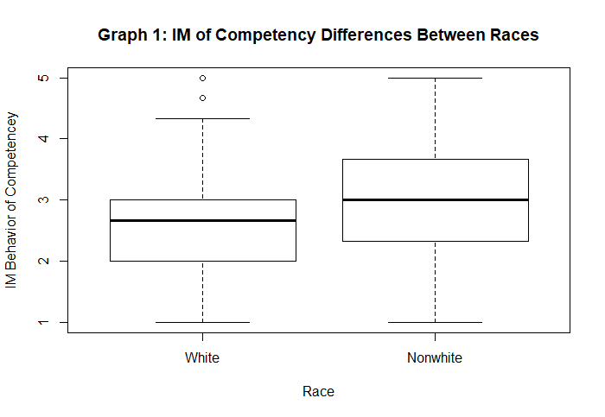

The tests are limited because the classifications of nonwhite and white employees may be too broad. Stereotypes are largely race specific, and a more focused classification may lead to different results. The next section investigates how impression management behaviors around likeability and competence differ between minority subgroups. Unfortunately, there was not enough data to examine these subgroups for hypothesis 2 or 3.

*5.2 Hypothesis 1: Nonwhite Subgroups Versus White*

The regression of impression management around likeability and competency was reran, but instead of grouping all minority groups into “nonwhite”, minority groups were split into subgroups. Graph 2 shows the minority subgroupings of the data. Individual races were limited and were therefore split into subgroups such as Blacks, Asians, and Hispanics or Latinos. Races that didn’t have enough members to run a regression were classified as “other”. The other classification consisted of groups such as Hawaiian or other Pacific Islander, American Indian or Alaskan Native. This grouping is not large enough to analyze but is worth separating to ensure accuracy in the other subgroup regressions.

The findings of the hypothesis around likeability for the subgroups are found in column 1 of Table 2. By running a regression, it was shown that my hypothesis around was not supported Asians and the “other” classification given the interaction term was not significant, therefore I fail to reject the null hypothesis that there is no difference, on average, between whites and nonwhite subgroups in term of impression management behavior for likability. Furthermore, Blacks and Hispanics or Latinos was also not supported. Conversely, the results showcased that Black employees exhibit less impression management likeability behaviors on average as compared to their white counterparts at a p-value less than .001. Meanwhile, Hispanics or Latinos also exhibited less impression management likeability behaviors on average as compared to their white counterparts at a p-value less than .05.

The second part of hypothesis 1 conjectured that nonwhite employee subgroups would report higher impression management around competence. The findings from the regression are shown in column 2 of Table 2. I find support for this hypothesis for Blacks at the 5% significance level, Asians at the 1% significance level, and Hispanics or Latinos at the 1% significance level. Therefore, there is a positive difference between all the minority subgroups and whites on impression management competency behaviors. Blacks report 0.286, Asians .349, and Hispanics or Latinos .405 higher for competence on a 7-point scale relative to white employees, controlling for gender, hours, experience, educational levels, and marriage. These differences can also be seen within Graph 3 of the box plot visualization below.

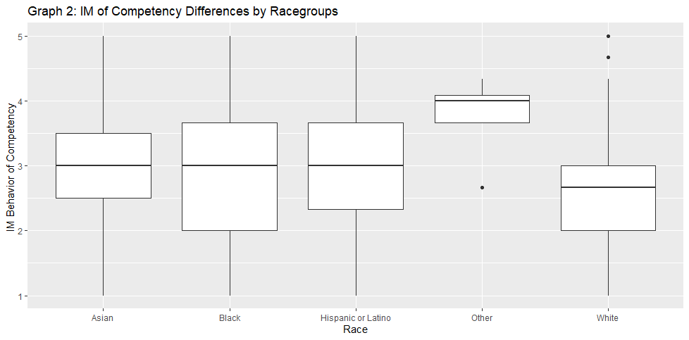

*5.3 Hypothesis 2 and 3*

The first part of hypothesis 2 conjectured that nonwhite employees who have white managers would have higher impression management around likeability. The findings from the regression are shown in column 1 of Table 3. By running a regression, it was shown that my hypothesis was not supported given the coefficient on the interaction term was not significant. Therefore, I failed to reject the null hypothesis that there is no difference, on average, in impression management behavior for likability between nonwhite and white employee based on whether the manager is white.

The second part of hypothesis 2 conjectured that nonwhite employees who have white managers would have higher impression management around competency. The findings from the regression are shown in column 2 of Table 3. By running a regression, it was shown that my hypothesis was not supported given the coefficient on the interaction term was not significant. Therefore, I failed to reject the null hypothesis that there is no difference, on average, in impression management behavior for competency between nonwhite and white employee based on whether the manager is white.

The first part of hypothesis 3 conjectured that nonwhite employees in a workgroup with a higher percentage of whites would report higher impression management around likeability. The findings from the regression are shown in column 1 of Table 4. By running a regression, it was shown that my hypothesis was not supported given the coefficient on the interaction term was not significant. Therefore, I failed to reject the null hypothesis that there is no difference, on average, in impression management behavior for likeability between nonwhite employees in a workgroup with a higher percentage of whites.

The second part of hypothesis 3 conjectured that nonwhite employees in a workgroup with a higher percentage of whites would report higher impression management around competency. The findings from the regression are shown in column 2 of table 4. By running a regression, it was shown that my hypothesis was not supported. Therefore, I failed to reject the null hypothesis that there is no difference, on average, in impression management behavior for competency between nonwhite employees in a workgroup with a higher percentage of whites. Conversely, the results showcased that non-white employees are less likely to exhibit impression management behaviors on competency relative to white employees when there is a higher percentage of white employees (relative to a lower percent).

These results showed that nonwhite employees display higher impression management behaviors around competency, but not when they are in a workgroup with a higher percentage of nonwhite employees.

*5.4 Limitations*

There were several limitations to this study regarding the lack of data and definition of a workgroup. First, hypothesizes 2 and 3 broadly classified minority races as nonwhite. This broad classification may miss differences in race combinations of manager and subordinate, such as same race pairings for minority subgroups. Furthermore, some races have greater stereotypes around likeability or competency than others that may be missed when conducting the regression. Moreover, the third hypothesis’s workgroup variable may not be representative because of the limited qualifications for being considered in a workgroup. Workgroups are based on having the same manager rather than an explicit measure of employee interaction with one another. Employees who interact more with one another may have stronger impression management than those who interact less, or vice versa.

**6. Discussion**

The results from the regressions carried a general theme that nonwhite employees exhibit impression management behaviors around competency but not likeability. This may be because competency behaviors are more directly tied to promotions and advancements in careers than likeability behaviors. Promotions are rooted from job performance, and therefore impression management behaviors such as reminders about talents can be more effective in driving promotions than likeability measures. Nonwhite employees may not believe that impression management behaviors around likeability are worth doing. This theme is shown in Hypothesis 1’s result about how white employees had higher impression management behaviors around likeability relative to nonwhite employees. If negative stereotypes exist around a minority workers’ likeability, they may feel uncomfortable socializing or engaging in likeability impression management behaviors. In the absence of negative stereotypes, white employees may feel more comfortable than nonwhite employees to compliment or praise others.

Hypothesis 2 was about the relationship between manager race and employee race regarding likeability and competency impression management behavior and was not supported. One reason for this may be because impression management may vary amongst position levels. Although I expected increase impression management for employees interacting with their managers, employees may be more inclined to use impression management behaviors towards their peers. Furthermore, a more focused race classification than nonwhite may have led to different results.

Finally, hypothesis 3 regarding the relationship between workgroup diversity and impression management behavior on competency showed conflicting results with past research. For example, Stroshine and Brandl (2011) research on tokenism found that minorities in the workplace face increased visibility. This suggests that minorities would be more likely to engage in competency impression management behaviors to deal with increased scrutiny in performance when in majority white workgroups. One reason for my results conflicting with past research may be because of the lack of consideration around the degree of interaction between workers. This research broadly classifies workgroup as reporting to the same manager, but this misses the interaction between employees. Future research could somehow standardize this degree of interaction for a stronger analysis.

**7. Conclusion**

Through this research, I analyzed a survey of respondents rating how likely they are to display behaviors influencing other’s perception on how likeable and competent they are. I found that nonwhite employees are more likely than white employees to try to influence others on how competent they are in the workplace. The regressions failed to support my other hypotheses that nonwhite employees would have to display higher impression management around likeability. The regressions also failed to support that nonwhite employees with a white manager would display higher impression management, or that nonwhite employees in a less diverse workgroup would display higher impression management.

There were several limitations to the study. First, the regressions broadly classified minorities into a single group for hypothesis 2 and 3. Impression management may be different depending on race subgroups, and this broad classification may have skewed the data. Furthermore, for hypothesis 3, the definition of a workgroup within the survey doesn’t capture the different degrees in which employees interact with one another.

For additional research on this topic, I would recommend analyzing a more specific racial classification. Different races have different stereotypes affecting other’s perception of how competent or likeable they are. Hypothesis 2 and 3 could benefit from a narrower classification and may have different results. For hypothesis 3, it may be useful to specify the degree of interactions between employees in a workgroup, as the definition of a workgroup for this study may be too loose.

The implications of nonwhites exhibiting higher degrees of impression management around likeability and competency is that they may do so to combat racism and stereotypes. Further exploration on different race subgroups’ impression management behaviors will lead to a better understanding how stereotypes come to play in the workplace. It is possible that organizations can extrapolate learnings from this kind of research to implement biases trainings to combat against stereotypes in the future.

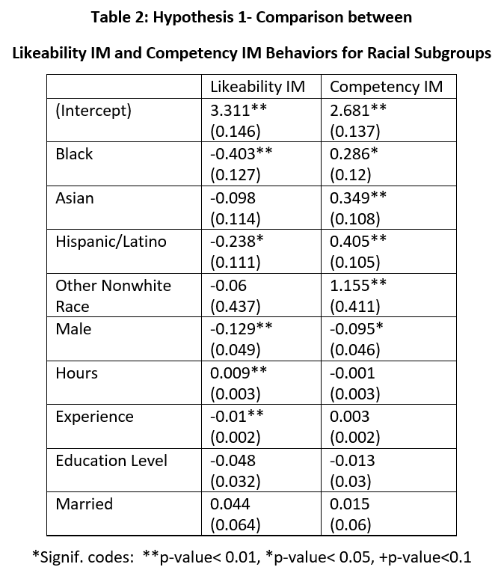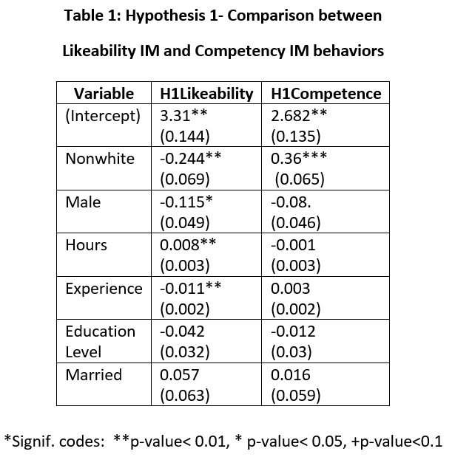**Appendix**

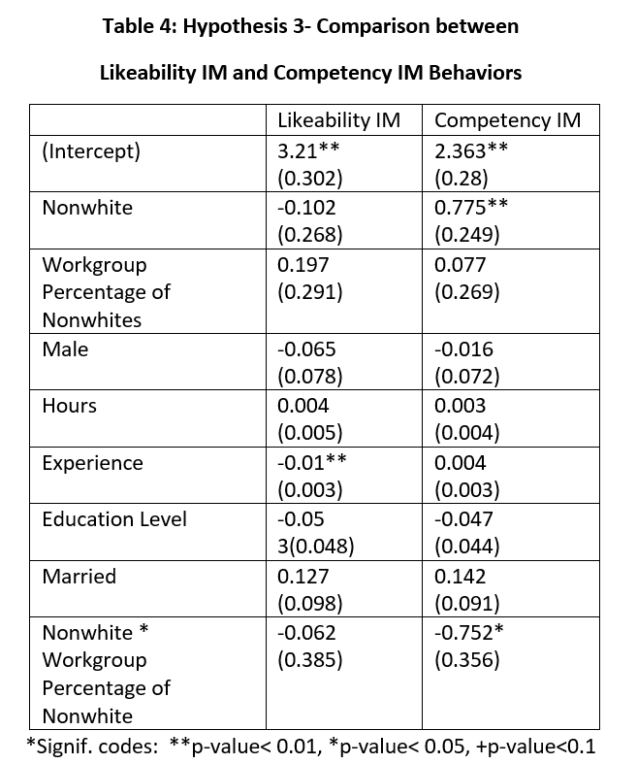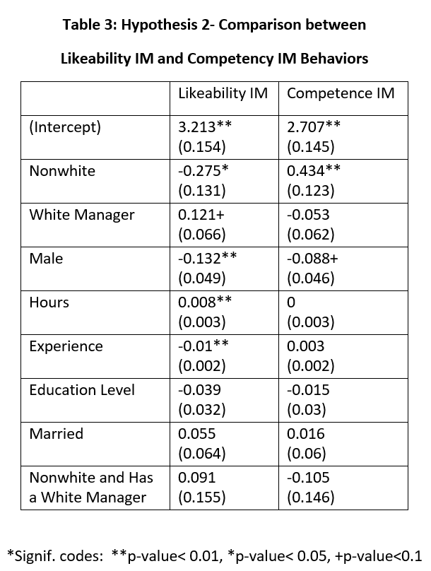

**Reference List**

Bolino, M. C., & Turnley, W. H. (1999). Measuring Impression Management in Organizations: A Scale Development Based on the Jones and Pittman Taxonomy. Organizational Research Methods, 2(2), 187–206. https://doi.org/10.1177/109442819922005

Cuddy, A. J. C., Fiske, S. T., & Glick, P. (2004). When Professionals Become Mothers, Warmth Doesn’t Cut the Ice. *Journal of Social Issues*, *60*(4), 701–718. https://doi-org.ezp1.lib.umn.edu/10.1111/j.0022-4537.2004.00381.x

Gordon, R. A. (1996). Impact of ingratiation on judgments and evaluations: A meta-analytic investigation. Journal of Personality and Social Psychology, 71(1), 54–70. doi:10.1037/0022- 3514.71.1.54

Gee, Buck & Peck, Denise. “Asian Americans Are the Least Likely Group in the U.S. to Be Promoted to Management.” *Harvard Business Review*, 31 May 2018, hbr.org/2018/05/asian-americans-are-the-least-likely-group-in-the-u-s-to-be-promoted-to-management.

Greenhaus, Jeffrey H., et al. “Effects of Race on Organizational Experiences, Job Performance Evaluations, and Career Outcomes.” Vol. 33, no. 1, 1990, pp. 64–86., doi:10.2307/256352. Accessed 10 Nov. 2019.

Gündemir, S., Homan, A. C., de Dreu, C. K., & van Vugt, M. (2014). Think leader, think White? Capturing and weakening an implicit pro-White leadership bias. PloS one, 9(1), e83915. doi:10.1371/journal.pone.0083915

Jones, E. E., & Pittman, T. S. (1982). Toward a general theory of strategic self-presentation. In J. Suls (Ed.), Psychological perspectives on the self (Vol. 1, pp. 231–261). Hillsdale, NJ: Erlbaum

Kenny, E. J., & Briner, R. B. (2013). Increases in salience of ethnic identity at work: The roles of ethnic assignation and ethnic identification. Human Relations, 66, 725–748. https://doi-org.ezp1.lib.umn.edu/10.1177/00187267124640

Landy, F. J., Shankster, L. J., & Kohler, S. S. (1994). Personnel selection and placement. Annual Review of Psychology, 45, 261-296.

Moss, P., & Tilly, C. (1996). “Soft” Skills and Race:: An Investigation of Black Men’s Employment Problems. Work and Occupations, 23(3), 252–276. https://doi.org/10.1177/0730888496023003002

Mount, M. K., Sytsma, M. R., Hazucha, J. F., & Holt, K. E. (1997). Rater-ratee race effects in developmental performance ratings of managers. Personnel Psychology, 50, 51-69.

Sackett, P. R., & DuBois, C. L. Z. (1991). Rater-ratee race effects on performance evaluation: Challenging meta-analytic conclusions. Journal of Applied Psychology, 76, 873-877

Stauffer, J. M., & Buckley, M. R. (2005). The Existence and Nature of Racial Bias in Supervisory Ratings. Journal of Applied Psychology, 90(3), 586–591. https://doi.org/10.1037/0021-9010.90.3.586

Stroshine, M., & Brandl, S. (2011). Race, Gender, and Tokenism in Policing: An Empirical Elaboration. *Police Quarterly,* *14*(4), 344-365.

Susuki, B. H. (2002). Revisiting the model minority stereotype: Implications for student affairs practice and higher education. New Directions for Student Services, 97, 21–32. https://doi-org.ezp1.lib.umn.edu/10.1002/(ISSN)1536-0695

Tajfel, H., & Turner, J. C. (1979). An integrative theory of intergroup conflict. In W. G. Austin & S. Worchel (Eds.), *The social psychology of intergroup relations* (pp. 33–47). Monterey, CA: Brooks‐Cole.

Thompson, Mischa & Sekaquaptewa, Denise. (2002). “When Being Different Is Detrimental: Solo Status and the Performance of Women and Racial Minorities.” *Analyses of Social Issues and Public Policy*, vol. 2, no. 1, pp. 183–203., doi:10.1111/j.1530-2415.2002.00037.x.